Introduction

What is this for?
Children can get easily worked up while doing certain activities and can also become anxious or nervous in certain settings, this product helps the child lower their breathing rate and regain their focus. This manual will show you how to build a device to help lower a child's breathing rate, by using a common technique of tracing the outside of the hand and breathing in and out.

This is for you if…
This was designed for anyone regularly working with young children one-on-one or in small groups. The product is compatible with children roughly ages 4 to 9 years old.

This product should stop being used if…
If the child or user has issues with flashing lights or vibration, the product should either be used with just the vibration and without the motor or vice versa. This product is meant to calm the user down, so if it increases anxiety, then stop using it.

Materials
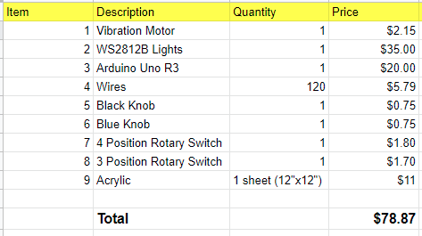

Acrylic Sheets
You can get sheets of the right material cut to the right size at your local plastic stores. Colorado Plastics was a great resource for us.

Arduino Circuitry
All the Arduino circuitry can be purchased through Amazon or various electronic companies such as Sparkfun or All Electronics. The main and necessary components for the setup of the Arduino, are an Arduino, LED strips, haptic motors, and rotary switches.

Arduino Uno R3 (Amazon)

Flexible LED Strip Light (Amazon)

Breadboard Jumper Wires (Amazon)

Haptic Motor (Sparkfun)

3 and 4 Position Rotary Switches (All Electronics)

Manufacturing the Parts

Box
We’ll be using a laser cutter to manufacture the acrylic pieces to fit together into a box shape. We’ve attached the .dxf files to be able to cut the pieces. The settings depend on the specific machine you are using, but you want to hairline (cut through) the edges, and this would be possible with acrylic.

Hand
We’ll be using a laser cutter to manufacture the acrylic piece for the hand. We’ve attached the .dxf files to be able to cut the piece. The settings depend on the specific machine you are using, but you want to hairline (cut through) the edge, and raster (engrave) the indentations of the LEDs to sit in, and this would be possible with acrylic.

LED Strip and Haptic Motor Programming
The provided code functions so that the LED strip and haptic motor run for a set amount of time as determined by the three position rotary switch. This would be either two, three, or four second intervals based on the patient’s size and corresponding target breathing rate. For example, if the switch is turned to the two second setting, the lights will trace up one side of the thumb and the haptic motor will vibrate for two seconds. Then, the entire apparatus will pause for a brief amount of time before repeating this process for the other side of the thumb, then for the remaining fingers. The lights are programmed such that no matter the length of the finger, it will take the predetermined amount of time to trace one side of that finger. This means that the LEDs will light up more quickly for the longer fingers with more LEDs to maintain a constant time to trace out each finger. This circuit is powered by a 9 Volt battery, and has a variety of other components such as a regulator, transistor, resistor, capacitor, and diode to regulate the flow of current and ensure that everything runs smoothly. Ideally, there would be another four position rotary switch which gives the user the option of having both the lights and motor run, only one of the two, or neither. This would be fairly easy to set up, repeating portions of the same provided code three times within a case structure for the switch, with another option for having everything off. For example, if the user turned the switch to the lights only setting, there would be an “if statement” with the provided block of code minus the lines to turn the haptic motor on and off. Although we had planned to include this component in our Tinkercad design, it was already running very slowly due to the Neopixel strips and haptic motor, so we decided to leave instructions for this second switch instead of integrating it into our circuit.

Assembling the Parts

The Circuit
To create the circuit, obtain all the required materials and find the schematics for wiring the Arduino. The schematics are located in the file with the .dxt files for the box. Carefully, wire the haptic motor, LED light strip, the switches, and the battery into the breadboard and Arduino. To get the circuit fully functioning, download the code onto the Arduino. To do this, plug the USB cable into the Arduino and get the code from the folder of files. Go to Choose Tools→Board→Arduino and find your board in the Arduino menu. Then, choose the correct serial port for your board and click the Upload button. Test the Arduino to make sure that the program has been loaded by testing the knobs. Then, the circuit should be complete for use.

The Box
To secure the different pieces of the box, the best way is to use acrylic cement. By injecting acrylic cement into the edges of the box, a clean bond can be made and the pieces will hold together. To do this, fill a syringe with acrylic cement. Then, holding the edges of the plastic together slowly release the acrylic cement from the syringe while moving along the whole edge. Finally, hold the pieces in the same position for approximately 5 minutes to let the cement solidify and bond. Repeat until all the edges have been bonded together. Let the box dry for 24 to 48 hours before adding the remaining components, to make sure that the box is sturdy for use.
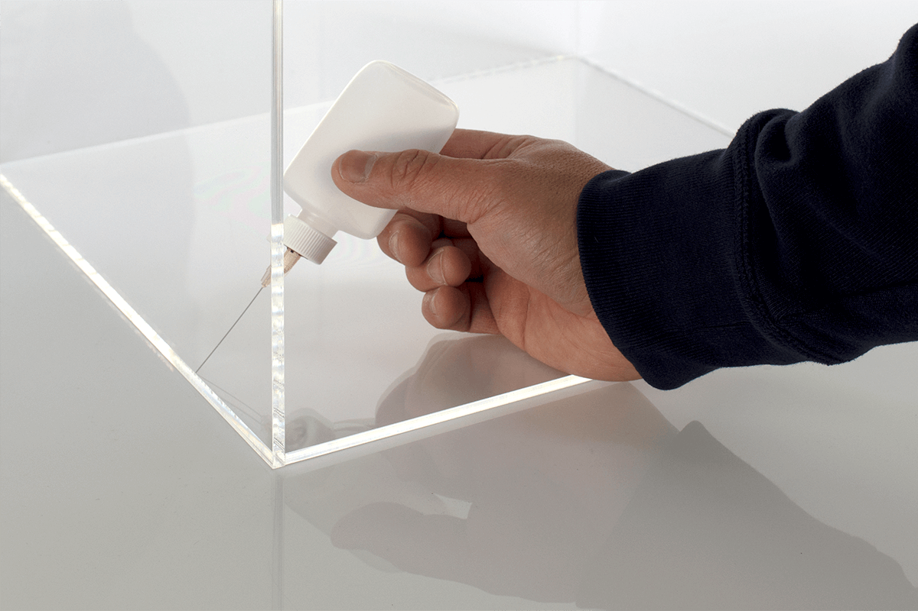
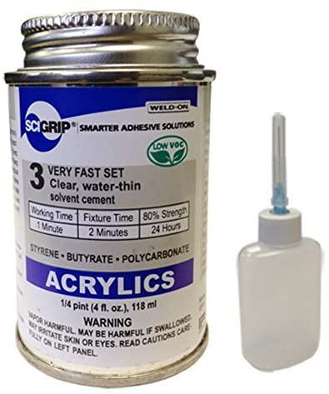
The image on the left shows how to hold the pieces and create a clean bond.

The image to the right is a common type of acrylic cement

The images below show how the pieces of the box go together.

LED Strips
Although in the Tinkercad model the LED strips are simply aligned in a rectangle, when assembling the box there is a divot in the hand into which the LEDs can be threaded to follow that shape. The clear acrylic of the hand portion will allow the light from the LEDs to shine through so that the child can trace the pattern of the colorful lights with his or her finger in time with the target breathing rate set by the machine. These LED strips will be wired to the Arduino Uno inside the box as demonstrated in the digital models provided.

